Homework 2

John Hardy

17 February 2019

Professor Johnson

5.1) In *component-based architecture*, you regard the system as a collection of loosely coupled components that provide services for each other. A *service-oriented architecture* is similar to a component-based architecture except the pieces are implemented as services. A *service* is a self-contained program that runs on its own and provides some kind of service for its clients.

5.2) For tic-tac-toe, the component based architecture would be the best choice since the entire game is contained entirely inside the phone and does not need external services.

5.4) For a chess game that allows players to communicate over the internet, the best choice would be to implement a service oriented architecture since the entire game is spread out over multiple separate computers that need separate services working together.

5.6) Since ClassyDraw is such a simple application, I would not use a full-fledged relational database, but rather a simple set of XML files to store information. We would not be saving older versions of saved content, so there is no maintenance required.

5.8) 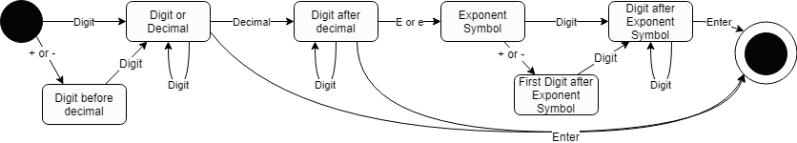

6.1) All classes share the position property and the bounding box properties which determine the location of the upper right and lower left corners. Rectangles, Ellipses, Stars and Text have a fill color property. Only the text box has a text information property. All shared properties like position and bounding box information should be held in one XML file with object identifiers for each object in the scene. The text boxes will have their own XML file for all of the text information. The same goes for shapes that can be filled.

6.2)

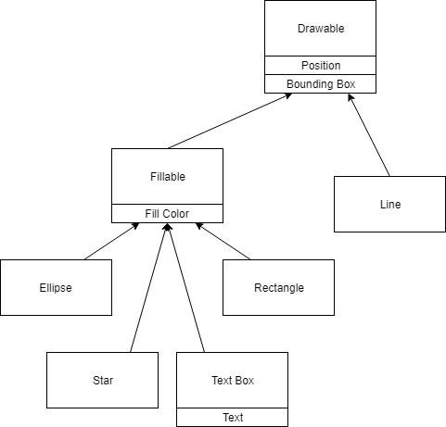

6.3)

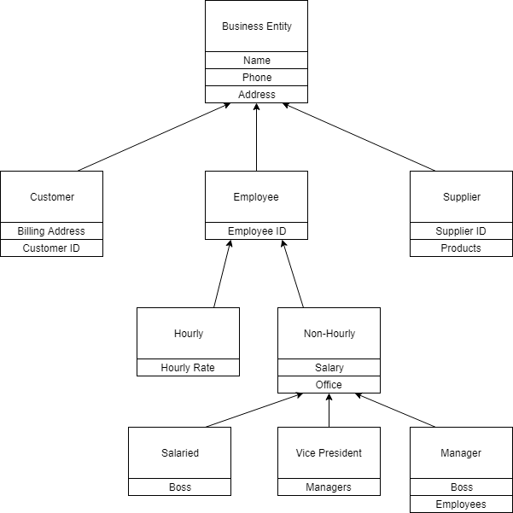

6.6)

